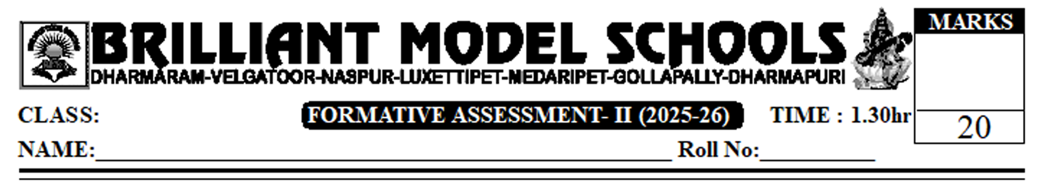

VIII Social

I. Answer the following questions. 2x2=4
1. In what ways have cheques made exchange of money more convenient?
2. Write any two advantages of Mobile phones.
II. Answer the following questions. 2x3=6
3. A) What comes under Service Sector? What is the technological change in it? (or)
B) Who were the contributors to this Industrial Revolution?
4. A) Do you feel that the loans taken from SHGs are helpful to the members? How? (or)
B) What is the difference between Saving account and Current Account.
III. Answer any one of the following question. 1x4=4
5. What are the advantages of using CH (Combined Harvester) in agriculture production?
Or
Read the following paragraph and answer the following questions.
Over time, people preferred scarce and attractive metals as a medium of exchange. Copper, bronze, silver and gold are durable, can be divided into parts and be carried around. Since they were scarce, they became acceptable by all. However some problems remained and new problems came up. For every exchange the metal had to be weighed and later on, traders were not sure about the quality of the metal. What one might get in exchange may not be pure gold or silver. After some time, there was a serious problem of trust in the quality of metal that was used as money for exchange.
1. Name some durable metals.
2. Are all the problems solved with the invention of money?
3. people preferred scarce and attractive metals as ______
4. Why were metals preferred for use as money?
IV. Locate the following places in India Map. 4x1/2=2
- Sikkim b) Punjab c) Goa d) Gandhi Nagar

PART - B.
V. Choose the correct answer. 8x1/2 = 4
- Pana was the standard currency in the ____ period.. ( )
A) Mauryan. B) Sindhu C) Mughal D) Aryan
- Money is ____ in Bank. ( )
A) dangerous B) safe C) expensive D) useless
3. Amsterdam was a major trading centre in ____ ( )
A) Europe B) Eurasia C) Russia D) U.S.A
4. ATM means ( )
A) Automatic Teller machine B) Automated Teller machine C) Automatic Telling machine
D) Automated Tellers machine
5. After Independence the government began building ____. ( )
A) temples B) palace C) farm houses D) Dams.
6. Henry Ford of ____ started the Assembly line method of production to produce more cars quickly.
( )
A) Canada B) Britain C) U.S.A D) China
7. Plastic is used instead of ( )
A) Rubber B) Copper C) Gold D) Platinum.
8. The __________ Introduced powerlooms in india ( )
A) British B) French C) Dutch D) Portuguses

